1. Define a function called greet that logs “Hello!” to the console. Call the function after defining it.

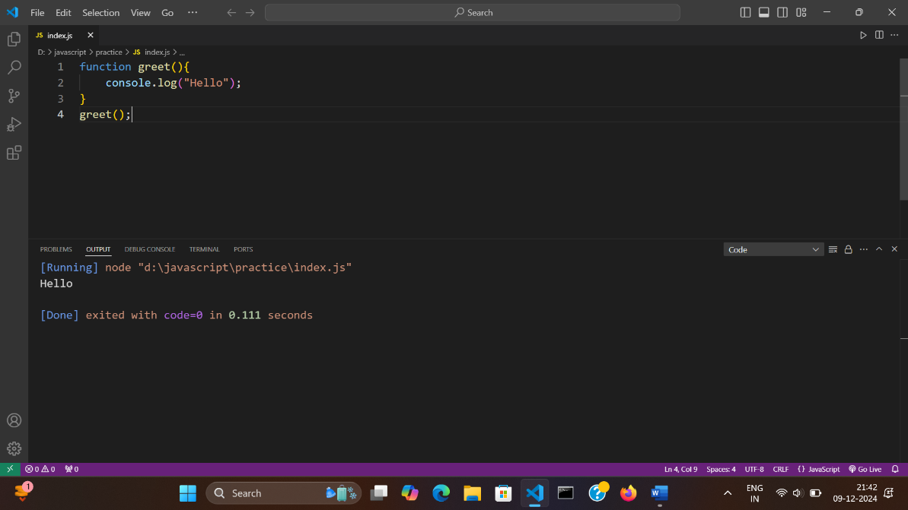

1. Write a function named showMessage that logs “This is a message!” to the console. Call the function once after defining it.

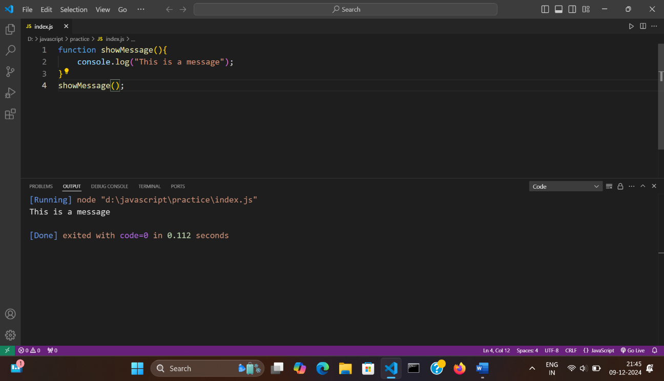

1. Create a function called logInfo that prints “Logging Information…” to the console. Call the function after defining it.

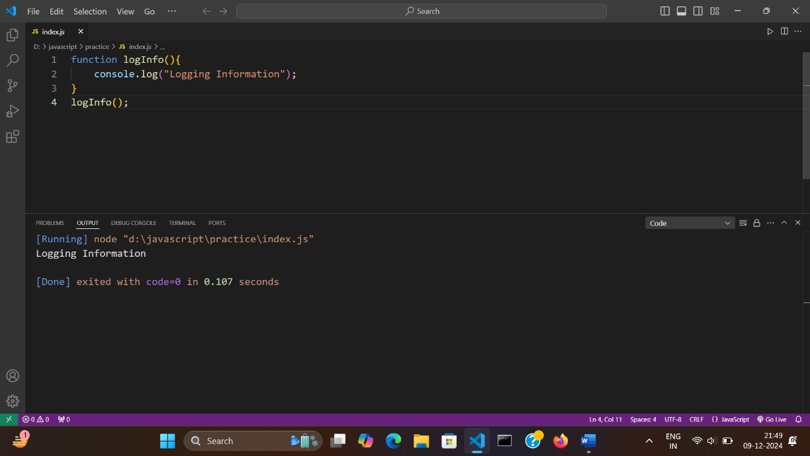

1. Define two functions:
   * startGame that logs “Game Started!”
   * endGame that logs “Game Over!”  
     Inside the startGame function, call the endGame function.

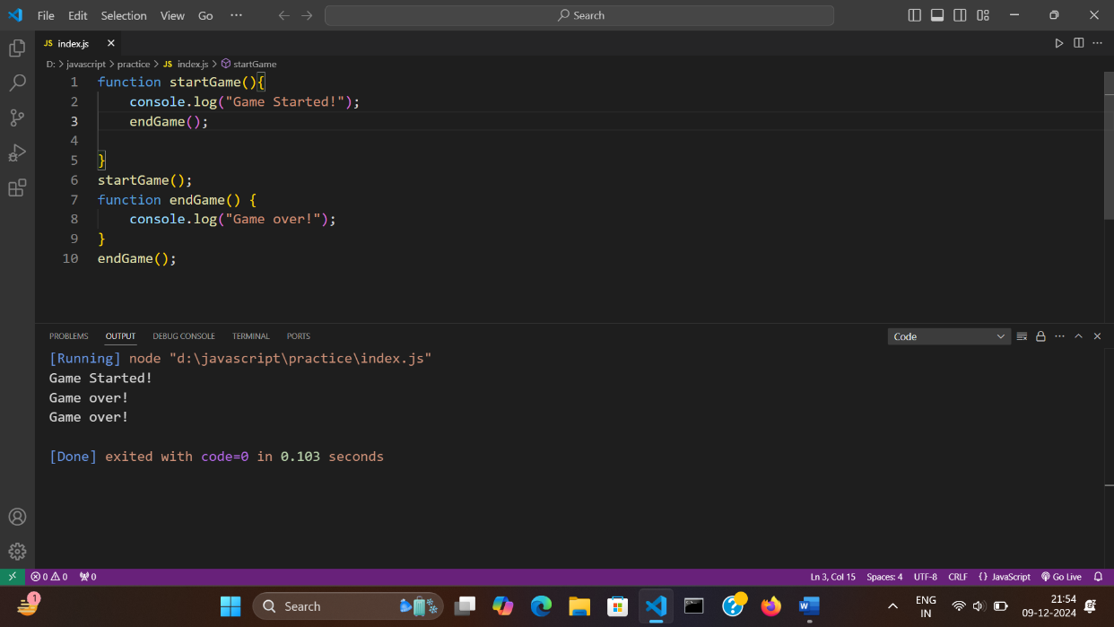

1. Create two functions:
   * beginTask that logs “Task Started”.
   * finishTask that logs “Task Finished”.  
     Inside the beginTask function, call the finish Task function.

